**Project:** Manufacturing Simulation

**Name:** OmarHisham Abdelhakam Zaghloul

**Student Number: 20201701079**

**The simulation:**

The project is a simulation of a manufacturing system, which is the system that has the parts getting processed in multiple stages. In the system, it contains some tasks such as inspecting, loading, machining, assembling, assembling, and packaging. Additionally, it contains a specific maintaining time and rate of breakdown as shown in algorithm 1.

# defining the precessing times for multiple operations

processingTime = {

    'loading': 5,

    'machining': 10,

    'assembling': 8,

    'inspecting': 6,

    'packaging': 4

}

# defining values for the estimated time and the breakdown rate

maintainance = 2

breakdown = 0.3

Algorithm 1, the definition of the processing time for each task, the maintainance time and the breakdown rate

Furthermore, it has a specific number of workers for each one of the tasks. Also taking into consideration of other parameters such as the length of the shifts, the time of the simulation, as well as number of products, which are demonstrated in Algorithm 2

# getting the number of workers in each operation

NWorkers = {

    'loading': 2,

    'machining': 3,

    'assembling': 4,

'inspecting': 2,

    'packaging': 3

}

# defining the shift in length, the simulation time and the number of products

shiftLength = 4

simulationTime = 100

Nproducts = 2

Algorithm 2, the definition of the number of workers in each task, alongside with the length of shifts, the simulation time, and the number of products.

After defining the main parameters for the simulation, it moves forward to the required stages for the simulation as defined withing the class named MLine and its functions of initializing, process, and repair. Beginning with defining the environment for the simulation, moving to setting up the resources for every task, then simulating how each part is processed in each stage, and finally simulating the process of the repair.

Going further with the simulation, we go to the setup of the environment, using the function of manufacturer, taking into consideration the environment, the ID for each part, as well as the type of each product, then it starts the manufacturing process. After that, there is a function that sets up the environment to start the process.

**Output:**

Lastly, after we run the simulation, it will execute the required data as shown in the following figure. As it creates the environment, sets up the initialized process and runs for the given simulation time that is defined within the simulation.

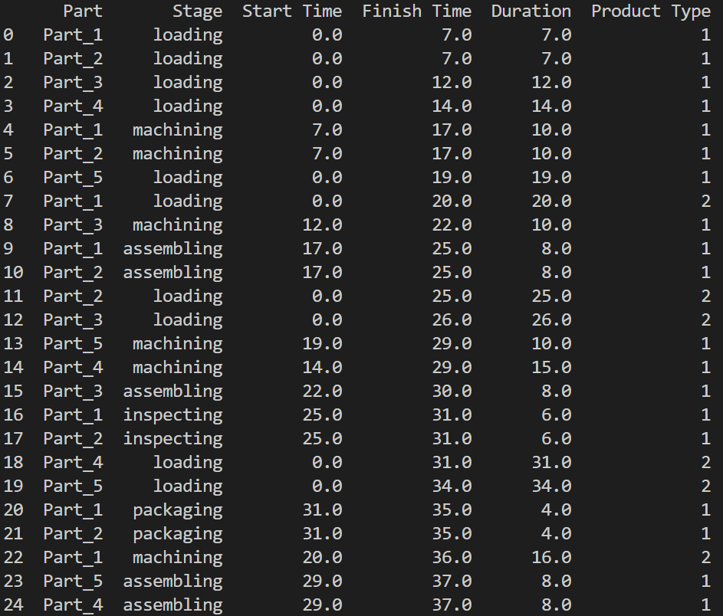

Figure 1, part of the initialized data of the simulation

**The used tools:**

Within this project, we used the programming language python to simulate the system. Within the simulation, we used multiple libraries to help us in the project, such as:

* Simpy: to model the events, manage the resources and process the resources
* Pandas: to do a data analysis of the collected data from the manufacturing process
* Random: to generate random numbers that would help implementing and simulating the system